1st Synergy masterclass marketing package:
Management & Leadership

Title: Synergy Masterclass on "Management and Leadership"
Dates: 5-6 October 2018
Link to website: http://www.eahp.eu/synergy-masterclass/events/leadership
Contact email: registration@eahp.eu

Synergy Masterclass Venue:
Hotel Van der Valk Brussels Airport
Culliganlaan 4b
1831 Diegem (Brussels), Belgium
Brussels
Hotel website: https://www.hotelbrusselsairport.com/en

Hotel accommodation:
Hotel Van der Valk Brussels Airport
Culliganlaan 4b
1831 Diegem (Brussels), Belgium
Brussels

Registration deadline: 10 August 2018

Registration fees:
The registration fees are set as follow (VAT excluded, 21% will be added at the end):
- Non-Members € 400 (VAT excluded)
- EAHP Members € 200 (VAT excluded)

The registration fee includes the attendance to the 2-day Synergy Masterclass, 2 coffee breaks per day, 1 lunch per day and the Synergy Masterclass package including all the printed materials.

Registration link: http://www.eahp.eu/synergy-masterclass/events/leadership/registration

Short description:
EAHP is glad to announce the expansion of the Synergy programme to provide continuing education and further advance the hospital pharmacy profession throughout the world.

In the first EAHP Synergy masterclass the themes of leadership and management will be explored, in particular the difference between these two concepts. In a nutshell, ‘Management is doing things right; leadership is doing the right things‘ (Drucker. P).

Long description:

EAHP is glad to announce the expansion of the Synergy programme to provide continuing education and further advance the hospital pharmacy profession throughout the world.

In the first EAHP Synergy masterclass the themes of leadership and management will be explored, in particular the difference between these two concepts. Leadership is to do with vision, in particular being able to communicate a vision and getting buy–in, it’s about motivating people and inspiring them.

Management, on the other hand, is to do with goals, targets, staffing, budgeting, performance management and problem solving. Managers build teams and ensure they function efficiently and effectively, whereas leaders inspire them. In a nutshell, “Management is doing things right; leadership is doing the right things” (Drucker. P).

Organiser: European Association of Hospital Pharmacists (EAHP)

Website organiser: http://www.eahp.eu

Short description organiser:
The European Association of Hospital Pharmacists represents more than 21.000 hospital pharmacists in 35 European countries and is the only association of national organisations representing hospital pharmacists at European and international levels.

Pictures:

EAHP LOGO
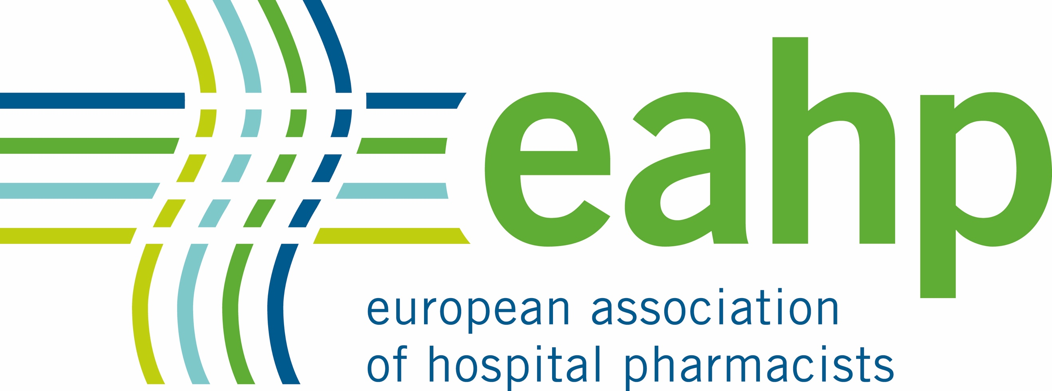
Banner for synergy masterclass

